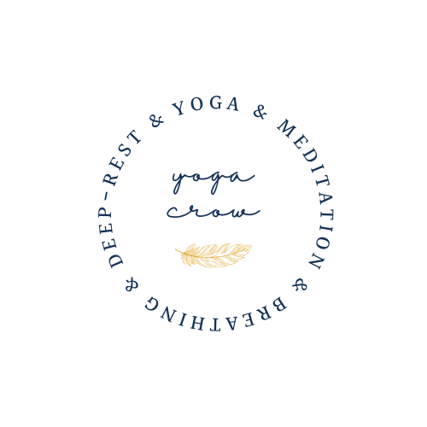
YogaCrow.UK
CONFIDENTIAL HEALTH QUESTIONNAIRE
Revised 23rd December 2020

For completion by yoga class participants for either face to face or remote class teaching before the first class commences.
All information given will be treated in the strictest confidence and stored in accordance with General Data Protection Regulations
It is entirely up to you what, or how much, information you disclose. You can leave all or any sections blank, but we draw your attention to the disclaimer overleaf because you must be responsible for your own health if you do not disclose.
Name:
Date of Birth:
Address:
Post Code:
Telephones / Mobile (Day & Evening):
Email (PLS INDICATE IN BLOCK CAPITAL LETTERS):
Emergency Contact Name:
Emergency Contact Phone Number:
RELEVANT HEALTH PROBLEMS:
Have you had any major health problems in the past or are you currently dealing with the medical profession?
Such problems might include high or low blood pressure, recent surgery, epilepsy, diabetes, serious injury or accident, abdominal disorder, auto-immune disorder such as M.E. M.S. Lupus etc., asthma, ulcers, hernias, arthritis, problems with the back, hip, shoulder, neck, the heart, knees, eyes such as detached retina or glaucoma, ears, balance disorder or mental health – anxiety/depression.

Please give further information on any issues indicated above that you want to make your teacher aware of, or anything else that you wish to bring to your teacher’s attention:

How did you hear of this class?
Have you attended a yoga class before? If so, how long have you practiced yoga?
What other physical activities do you participate? (If none, please leave this section blank)
Are you/could you be pregnant, or have you given birth in the last eight weeks?
Yoga covers a wide range of disciplines which include flexibility, strength, stamina, breathing, relaxation, mental awareness, spirituality. All these will enable you to deal positively with life. However, are there any particular aspects of yoga that interest you specifically:

Please tick this box if you DO NOT wish to declare physical and/or mental health information:
It is your right to withhold information but we must inform you that if you do not disclose your health status, your teacher cannot give modifications or alternatives for physical conditions that have not been declared, and will be unaware of anything that might cause emotional distress or otherwise exacerbate any mental health issues.
Have you ever been tested positive for Covid-19?
Have you been vaccinated for Covid-19?
Are you / could you be going through any stages of menopause?
Is there anything else you would like to tell your teacher?

Disclaimer
Please read carefully; your submission of this form will be taken to indicate your understanding and acceptance of the following:
Please take care when filling in this questionnaire and check the contents are accurate before you submit it. By submitting this form, you are confirming that the contents are true and accurate to the best of your knowledge. Please notify your teacher of any changes to your responses in this healthcare questionnaire before participating in classes subsequent to those changes.
Neither your teacher nor the British Wheel of Yoga are qualified to express an opinion that you are fit to safely participate in any British Wheel of Yoga organised sessions or any British Wheel of Yoga trained teacher’s yoga classes. You must obtain professional or specialist advice from your doctor before participating if you are in any doubt.
All British Wheel of Yoga, Accredited Group teachers or Recognised Teachers are appropriately qualified, with high standards of teaching and best practice. Where possible, your teacher may offer suitable modifications or adjustments and practices to suit different levels of experience and ability.
Please always let the teacher know before the class if this is your first time practicing yoga or if you are not confident about your experience and/or ability. Where you are taking part in live-streamed classes, please note that the instructor may not be able to see you at all times. Where you have declared a health condition, please contact the teacher before the class if you would like to request that you are provided with suitable modifications or adjustments wherever possible. Please note, where you are taking part in a pre-recorded class, you will not be able to request specific adjustments or modifications.
In all classes whether face to face, live streamed remote or pre-recorded remote, always follow your teacher’s safety instructions and listen to your body. Where a movement or class is beyond your experience or ability, feels too difficult for you, or you experience any physical or emotional discomfort, please do not continue.
If you do not return this questionnaire to your teacher prior to taking part in one of our classes, your teacher will assume that you do not have any existing health conditions or concerns to declare. Please contact your teacher immediately if your circumstances change or speak with your yoga teacher prior to taking part in a class if you have any concerns. Your teacher will be unable to make modifications or adjustments to the exercises for health conditions or concerns that are not declared. Your teacher will not be responsible where you fail to return the health questionnaire, or where you do not declare a health condition to your teacher or to BWY (whether by returning the questionnaire or in some other communication), and an issue arises as a result.
Signature  if using a printed-out paper copy: Otherwise indicate with your initials, tick or X | I confirm my understanding and acceptance of this health questionnaire and its disclaimer:
Date:
GDPR Statement
In order to comply with the General Data Protection Regulations, it is necessary for me to inform you that I occasionally send you information that I think may be useful to you, including training and events, news, offers & discounts, timetable and venue changes and relevant updates. I only send information when it is necessary to do so in order for you and me to carry out our practices together. On each occasion that I contact you in the future you will be given the option to opt-out from receiving such messages. To ensure that I only communicate with you in the manner of your preferred choice, please let me know if you DO NOT agree to receive such messages in the future.

